**Confusion Matrix - Metrics**

Confusion matrix is a matrix formed by checking the actual values and predicted values in a dataset. This matrix is used to evaluate the performance of the model that has been built.

In the below confusion matrix, the columns represent the predicted values and rows represent the actual values.

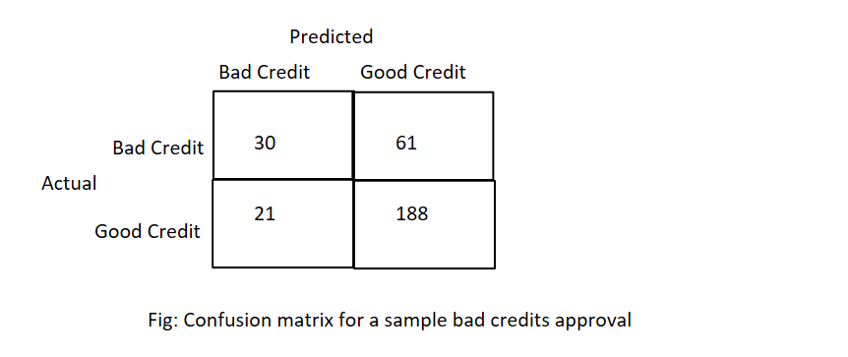

In the above sample example, out of 91 bad credits, the model has predicted 30 bad credits correctly and the rest 61 has been identified as good credits.

1. True positive (TP): The top left quadrant represent bad credits and is correctly classified as bad credits
2. False Positive (FP): The bottom left quadrant represent good credits and is incorrectly classified as bad credits
3. False Negative (FN): The top right quadrant represent bad credits and is incorrectly classified as good credits
4. True Negative (TN): The bottom right quadrant represent good credits and is correctly classified as good credits.

**Measuring Accuracies:**

The model performance in classification is measured through concepts such as sensitivity, specificity, precision and F-score.

**Sensitivity or recall**: The ability of the model to correctly classify positives (actual is positive and predicted is also positive)

sensitivity = TP/(TP+FN)

**Specificity:** The ability of the model to correctly classify negatives (actual is negative and predicted is also negative)

specificity = TN/(TN+FP)

**Precision:** It is the probability of the actual value is positive given the model predicted positive values

precision = TP/(TP+FP)

**F-score:** It combines the precision and recall. It is the harmonic mean of precision and recall.

F-score = 2*Recall*Precision/ (Recall + Precision)